THE SUTTONS
Neighbourhood Policing Team

YOUR LOCAL TEAM
 |  | 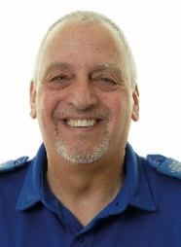
PC Paul Freeman |  | PCSO Dave Walker

FORTHCOMING ENGAGEMENTS
Fri 11th Nov 1000-1100 Market house long Sutton
Thursday 10th Nov 1000-1100 Curlew Centre
Further engagements will be posted on social media.

LOCAL PRIORITY
Every three months, we listen to your concerns and look at recent crime statistics to shape the things we will concentrate on for the next three months. Our priority(s) for the next quarter is:
Drugs use and supply within our area. We ask anybody with information regarding this to please let us know as only with your help can we stop this.
Our contact details are on the right. If you wish you can contact Crime Stoppers anonymously on 0800 555 111 or online at crimestoppers-uk.org
As always thank you for your help

WHAT’S BEEN HAPPENING
Hello once again from your policing team.
Thank you to everybody who has let us know about drugs within our community and the more information you can give us the more we can do to stop this problem.
Since my last update a search warrant under the misuse of drugs act was executed in Sutton Bridge and two people were arrested on suspicion of being concerned in the supply of controlled drugs. Investigations are ongoing.
Groups of youths once again have been congregating at the rear of the Curlew Centre and extra patrols of the area are ongoing
It appears that members of our community are happy to post on social media but not inform us via 101. Please call 101 to report issues to us. If we don’t know we can’t help.

PCSO Dave Walker
07973846299

Pc Paul Freeman
07973848231
holbeachandsuttons@lincs.police.uk

