THE SUTTONS
Neighbourhood Policing Team

YOUR LOCAL TEAM
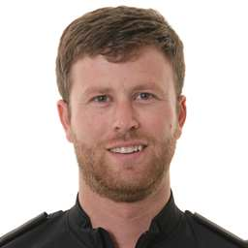 |  | 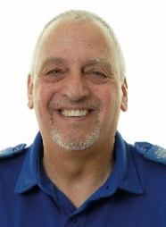
PC Jon Cummings |  | PCSO Dave Walker

FORTHCOMING ENGAGEMENTS
Thursday 4th May 1500-1600 Long Sutton Library
Tuesday 9th May 1100-1200 Curlew Centre
Friday 12thMay 1400-1500 Market house long Sutton

Further engagements will be posted on social media.

LOCAL PRIORITY
It has been decided that for the next three months we will increase our patrols in the parks in our area due to the better weather and lighter nights which can encourage more people to congregate.
Our Priority at present is Youth Related ASB.
Our contact details are on the right. If you wish you can contact Crime Stoppers anonymously on 0800 555 111 or online at crimestoppers-uk.org
As always thank you for your help

WHAT’S BEEN HAPPENING
Hello once again from your policing team,
First let me wish PC Paul Freeman happy retirement. He was well known in our community and will be missed. Let me also welcome PC Jon Cummings who has temporarily replaced Paul as he also covers Holbeach and Weston areas.
Due to ASB incidents within our area, first stage ASB warning letters have been issued to individuals and this process will be robustly followed.
As you can see the dates of the forthcoming engagements are to the left and if you wish to pop in for a chat please do.
It appears that members of our community are happy to post on social media regarding ongoing ASB and crimes and not inform us via 101. Please call 101 to report issues to us. If we don’t know we can’t help.
Please contact us and talk to us as only with your help can we make our community a better place to live and work.
Thank you for your positive feedback so far.
PCSO Dave Walker
07973846299

Pc Jon Cummings
07789001666
holbeachandsuttons@lincs.police.uk

